Inheritance in Java

**Inheritance in java** is a mechanism in which one object acquires all the properties and behaviors of parent object.

The idea behind inheritance in java is that you can create new classes that are built upon existing classes. When you inherit from an existing class, you can reuse methods and fields of parent class, and you can add new methods and fields also.

Inheritance represents the **IS-A relationship**, also known as parent-child relationship.

### **Why use inheritance in java**

* For Method Overriding (so runtime polymorphism can be achieved).
* For Code Reusability.

### **Syntax of Java Inheritance**

1. **class** Subclass-name **extends** Superclass-name
2. {
3. //methods and fields
4. }

The **extends keyword** indicates that you are making a new class that derives from an existing class. The meaning of "extends" is to increase the functionality.

In the terminology of Java, a class which is inherited is called parent or super class and the new class is called child or subclass.

### **Java Inheritance Example**

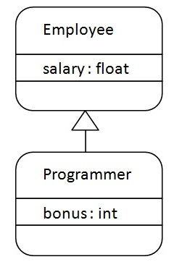

As displayed in the above figure, Programmer is the subclass and Employee is the superclass. Relationship between two classes is **Programmer IS-A Employee**.It means that Programmer is a type of Employee.

1. **class** Employee
2. {
3. **float** salary=40000;
4. }
5. **class** Programmer **extends** Employee{
6. **int** bonus=10000;
7. **public** **static** **void** main(String args[]){
8. Programmer p=**new** Programmer();
9. System.out.println("Programmer salary is:"+p.salary);
10. System.out.println("Bonus of Programmer is:"+p.bonus);
11. }
12. }

Programmer salary is: 40000.0

Bonus of programmer is: 10000

In the above example, Programmer object can access the field of own class as well as of Employee class i.e. code reusability.

## **Types of inheritance in java**

On the basis of class, there can be three types of inheritance in java: single, multilevel and hierarchical.

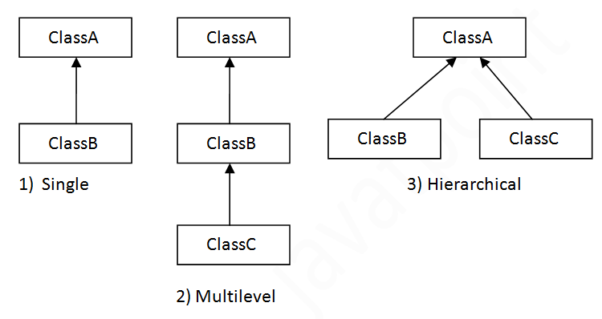In java programming, multiple and hybrid inheritance is supported through interface only. We will learn about interfaces later.

#### Note: Multiple inheritance is not supported in java through class.

When a class extends multiple classes i.e. known as multiple inheritance. For Example: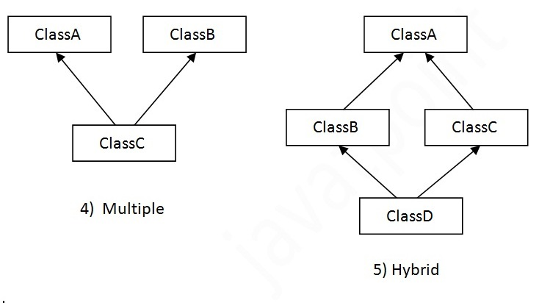

## **Single Inheritance Example**

*File: TestInheritance.java*

1. **class** Animal{
2. **void** eat(){System.out.println("eating...");}
3. }
4. **class** Dog **extends** Animal{
5. **void** bark(){System.out.println("barking...");}
6. }
7. **class** TestInheritance{
8. **public** **static** **void** main(String args[]){
9. Dog d=**new** Dog();
10. d.bark();
11. d.eat();
12. }}

Output:

barking...

eating...

## **Multilevel Inheritance Example**

*File: TestInheritance2.java*

1. **class** Animal{
2. **void** eat(){System.out.println("eating...");}
3. }
4. **class** Dog **extends** Animal{
5. **void** bark(){System.out.println("barking...");}
6. }
7. **class** BabyDog **extends** Dog{
8. **void** weep(){System.out.println("weeping...");}
9. }
10. **class** TestInheritance2{
11. **public** **static** **void** main(String args[]){
12. BabyDog d=**new** BabyDog();
13. d.weep();
14. d.bark();
15. d.eat();
16. }}

Output:

weeping...

barking...

eating...

## **Hierarchical Inheritance Example**

*File: TestInheritance3.java*

1. **class** Animal{
2. **void** eat(){System.out.println("eating...");}
3. }
4. **class** Dog **extends** Animal{
5. **void** bark(){System.out.println("barking...");}
6. }
7. **class** Cat **extends** Animal{
8. **void** meow(){System.out.println("meowing...");}
9. }
10. **class** TestInheritance3{
11. **public** **static** **void** main(String args[]){
12. Cat c=**new** Cat();
13. c.meow();
14. c.eat();
15. //c.bark();//C.T.Error
16. }}

Output:

meowing...

eating...

## **Q) Why multiple inheritance is not supported in java?**

To reduce the complexity and simplify the language, multiple inheritance is not supported in java.

Consider a scenario where A, B and C are three classes. The C class inherits A and B classes. If A and B classes have same method and you call it from child class object, there will be ambiguity to call method of A or B class.

Since compile time errors are better than runtime errors, java renders compile time error if you inherit 2 classes. So whether you have same method or different, there will be compile time error now.

1. **class** A{
2. **void** msg(){System.out.println("Hello");}
3. }
4. **class** B{
5. **void** msg(){System.out.println("Welcome");}
6. }
7. **class** C **extends** A,B{//suppose if it were
9. public Static **void** main(String args[]){
10. C obj=**new** C();
11. obj.msg();//Now which msg() method would be invoked?
12. }
13. }

Compile Time Error

# What is Inheritance in Java Programming?

BY CHAITANYA SINGH | FILED UNDER: [**OOPS CONCEPT**](http://beginnersbook.com/category/oops-concept/)

**Inheritance**is one of the feature of Object-Oriented Programming ([**OOPs**](http://beginnersbook.com/2013/04/oops-concepts/)). Inheritance allows a class to use the properties and methods of another class. In other words, the derived class inherits the states and behaviors from the base class. The derived class is also called subclass and the base class is also known as super-class. The derived class can add its own additional variables and methods. These additional variable and methods differentiates the derived class from the base class.

Inheritance is a [**compile-time**](http://beginnersbook.com/2013/04/runtime-compile-time-polymorphism/) mechanism. A super-class can have any number of subclasses. But a subclass can have only one superclass. This is because Java does not support multiple inheritance.

The superclass and subclass have **“is-a”** relationship between them. Let’s have a look at the example below.

## Inheritance Example

Let’s consider a superclass Vehicle. Different vehicles have different features and properties however there few of them are common to all. Speed, color, fuel used, size are few which are common to all. Hence we can create a class ‘Vehicle’ with states and actions that are common to all vehicles. The subclass of this superclass can be any type of vehicle. Example: Class Car  A has all the features of a vehicle. But it has its own attributes which makes it different from other subclasses. By using inheritance we need not rewrite the code that we’ve already used with the Vehicle. The subclass can also be extended. We can make a class ‘Sports Car’ which extends ‘Car’. It inherits the features of both ‘Vehicle’ and ‘Car’.

The keyword used for inheritance is extends. Syntax:

public class ChildClass extends BaseClass {

// derived class methods extend and possibly override

}

Here is the complete example:

// A class to display the attributes of the vehicle

class Vehicle {

String color;

int speed;

int size;

void attributes() {

System.out.println("Color : " + color);

System.out.println("Speed : " + speed);

System.out.println("Size : " + size);

}

}

// A subclass which extends for vehicle

class Car extends Vehicle {

int CC;

int gears;

void attributescar() {

// The subclass refers to the members of the superclass

System.out.println("Color of Car : " + color);

System.out.println("Speed of Car : " + speed);

System.out.println("Size of Car : " + size);

System.out.println("CC of Car : " + CC);

System.out.println("No of gears of Car : " + gears);

}

}

public class Test {

public static void main(String args[]) {

Car b1 = new Car();

b1.color = "Blue";

b1.speed = 200 ;

b1.size = 22;

b1.CC = 1000;

b1.gears = 5;

b1.attributescar();

}

}

The output is

Color of Car : Blue

Speed of Car : 200

Size of Car : 22

CC of Car : 1000

No of gears of Car : 5

**Note:**  
The derived class inherits all the members and methods that are declared as public or protected. If declared as private it can not be inherited by the derived classes. The private members can be accessed only in its own class. The private members can be accessed through assessor methods as shown in the example below. The derived class cannot inherit a member of the base class if the derived class declares another member with the same name.

// A class to display the attributes of the vehicle

class Vehicle {

String color;

private int speed;

private int size;

public int getSize() {

return size;

}

public int getSpeed() {

return speed;

}

public void setSize(int i) {

size = i;

}

public void setSpeed(int i) {

speed = i;

}

}

// A subclass which extends for vehicle

class Car extends Vehicle {

int CC;

int gears;

int color;

void attributescar() {

// Error due to access violation

// System.out.println("Speed of Car : " + speed);

// Error due to access violation

//System.out.println("Size of Car : " + size);

}

}

public class Test {

public static void main(String args[]) {

Car b1 = new Car();

// the subclass can inherit 'color' member of the superclass

b1.color = 500;

b1.setSpeed(200) ;

b1.setSize(22);

b1.CC = 1000;

b1.gears = 5;

// The subclass refers to the members of the superclass

System.out.println("Color of Car : " + b1.color);

System.out.println("Speed of Car : " + b1.getSpeed());

System.out.println("Size of Car : " + b1.getSize());

System.out.println("CC of Car : " + b1.CC);

System.out.println("No of gears of Car : " + b1.gears);

}

}

The output is:

Color of Car : 500

Speed of Car : 200

Size of Car : 22

CC of Car : 1000

No of gears of Car : 5

#### Constructors and Inheritance

The [**constructor**](http://beginnersbook.com/2013/03/constructors-in-java/) in the superclass is responsible for building the object of the superclass and the constructor of the subclass builds the object of subclass. When the subclass constructor is called during object creation, it by default invokes the default constructor of super-class. Hence, in inheritance the objects are constructed top-down. The superclass constructor can be called explicitly using the keyword super, but it should be first statement in a constructor. The keyword super always refers to the superclass immediately above of the calling class in the hierarchy. The use of multiple super keywords to access an ancestor class other than the direct parent is illegal.

class Shape {

private int length;

private int breadth;

public int getBreadth() {

return breadth;

}

public int getLength() {

return length;

}

public void setBreadth(int i) {

breadth = i;

}

public void setLength(int i) {

length = i;

}

// default Constructor

Shape() {

length = 0;

breadth = 0;

System.out.println("Inside default constructor of Shape ");

}

// Parameterized Constructor

Shape(int len, int bdth) {

length = len;

breadth = bdth;

System.out.println("Inside constructor of Shape ");

System.out.println("length : " + length);

System.out.println("breadth : " + breadth);

}

}

// A subclass which extends for shape

class Rectangle extends Shape {

private String type;

// default Constructor

Rectangle() {

super();

type = null;

System.out.println("Inside default constructor of rectangle ");

}

// Parameterized Constructor

Rectangle(String ty, int len, int bdth) {

super (len, bdth);

System.out.println("Inside constructor of rectangle ");

System.out.println("length : " + len);

System.out.println("breadth : " + bdth);

System.out.println("type : " + type);

}

public String getType() {

return type;

}

public void setType(String string) {

type = string;

}

}

// A subclass which extends for rectangle

class ColoredRectangle extends Rectangle {

private String color;

/* default Constructor*/

ColoredRectangle() {

super();

color = null;

System.out.println("Inside default constructor of coloredRectangle");

}

// Parameterized Constructor

ColoredRectangle(String c, String ty, int len, int bdth) {

super (ty, len, bdth);

System.out.println("Inside constructor of coloredRectangle ");

System.out.println("length : " + len);

System.out.println("breadth : " + bdth);

System.out.println("type : " + ty);

}

public String getColor() {

return color;

}

public void setColor(String string) {

color = string;

}

}

public class Test {

public static void main(String args[]) {

ColoredRectangle CR = new ColoredRectangle();

ColoredRectangle CR2 = new ColoredRectangle("Red","Big", 5, 2 );

}

}

**The output is:**

Inside default constructor of Shape

Inside default constructor of rectangle

Inside default constructor of coloredRectangle

Inside constructor of Shape

length : 5

breadth : 2

Inside constructor of rectangle

length : 5

breadth : 2

type : null

Inside constructor of coloredRectangle

length : 5

breadth : 2

type : Big

#### Inheritance and Method Overriding

By using super we can access the [**overridden method**](http://beginnersbook.com/2014/01/method-overriding-in-java-with-example/) in the super class.

class Shape {

private int length;

private int breadth;

// default Constructor

Shape() {

length = 0;

breadth = 0;

}

// Parameterized Constructor

Shape(int len, int bdth) {

length = len;

breadth = bdth;

}

void showattributes() {

System.out.println("length : " + length);

System.out.println("breadth : " + breadth);

}

}

// A subclass which extends for shape

class Rectangle extends Shape {

private String type;

/* default Constructor

*/

Rectangle() {

type = null;

}

// Parameterized Constructor

Rectangle(String ty, int len, int bdth) {

super(len,bdth);

type = ty;

}

void showattributes() {

// showattributes() of class Shape is called

super.showattributes();

System.out.println("type : " + type);

}

}

public class Test {

public static void main(String args[]) {

Rectangle rect = new Rectangle("Blue",5,7);

// showattributes() in rectangle is called

rect.showattributes();

}

}

The output is :

length : 5

breadth : 7

type : Blue

#### Inheritance & Abstract Classes

The superclasses are more general than their subclasses. Usually, the superclasses are made abstract so that the objects of its prototype cannot be made. So the objects of only the subclasses can be used. To make a class abstract, the keyword abstract is used in the class definition.

Abstract methods are methods which do not have method statements. The subclasse provides the method statements. The methods provided by the superclass needs to be overridden by the subclass. The class that has at least one abstract method should be made abstract. The [**abstract class**](http://beginnersbook.com/2013/05/java-abstract-class-method/) can not be instantiated because it does not define a complete implementation.

public abstract class {

….

}

**Using Final with methods**: We can prevent a method from being overridden by using the keyword final at the start of its declaration. Final methods can not be overridden.

public abstract void methodname();

class Shape {

final void showattributes() {

System.out.println("Inside class shape ");

}

}

// A subclass which extends for shape

class Rectangle extends Shape {

void showattributes() { // Cannot override the final method

System.out.println("Inside class rectangle");

}

}

The method showattributes() cannot be overridden in the class rectangle because it is declared as final in class shape. It shows an error when we try to override it.

**Using Final with class**: We can also prevent inheritance by making a class final. When a class is declared as final, its methods also become final. An abstract class cannot be declared as final because an abstract class is incomplete and its subclasses need to provide the implementation.

final class shape {

void showattributes() {

System.out.println("Inside class shape ");

}

}

/* A subclass which extends for shape

*/

class rectangle extends shape {

// The type rectangle cannot subclass the final class shape

void showattributes() {

System.out.println("Inside class rectangle");

}

}

The class shape cannot be inherited because it is declared as final. It will show an error when we try to inherit it.